DS -542 PYTHON IN DATSCIENCE
PROJECT REPORT

DATA SET- HEALTHCARE INDUSTRY
- Patient ID
- Age
- Gender
- BMI
- Smoking Status
- Family History
- Glucose Level
- Cholesterol Level
- Blood Pressure
- Treatment Outcome

LIBRARIES
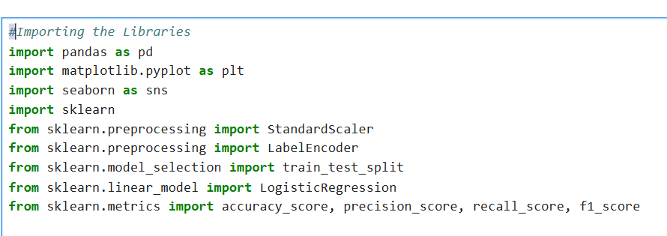

- Pandas: Used for data manipulation and analysis.
- NumPy: Provides support for numerical operations.
- Matplotlib & Seaborn: Libraries for data visualization.
- Scikit-learn: A machine learning library that provides tools for model training, evaluation, and preprocessing.

DATA IMPORTING

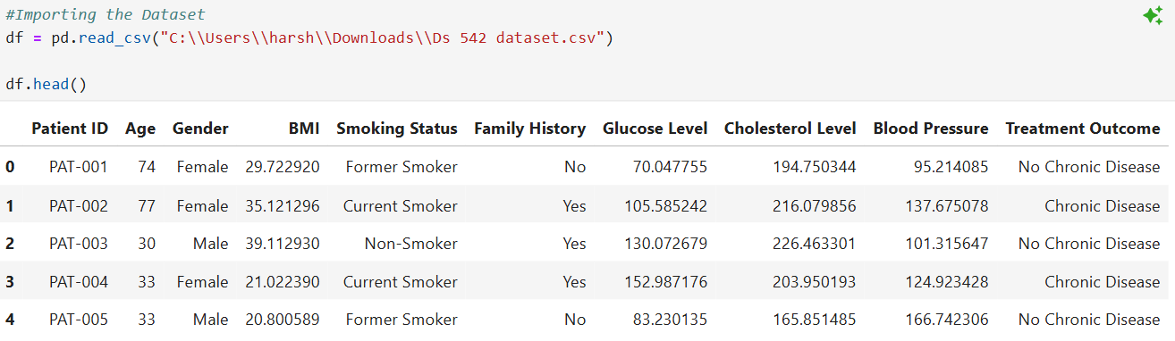

- The code imports a CSV file containing healthcare data into a dataframe called `df`. It then displays the first few rows of this dataset, which includes patient details like age, gender, BMI, and health metrics, allowing for an initial overview of the data.

DATA CLEANING
- Checking Missing Values

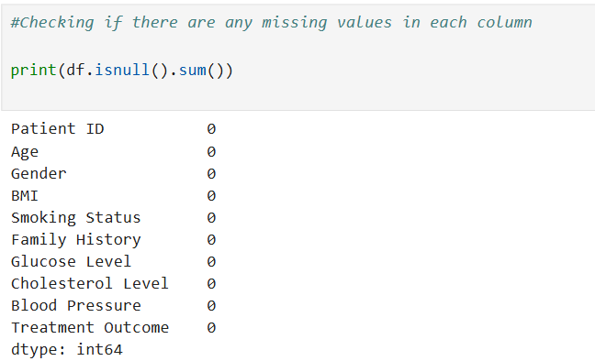
- The code checks for missing values in each column of the dataframe `df` by using the `isnull()` function, which identifies null entries, and `sum()` to count them. The output shows that there are no missing values in any of the columns, indicating a complete dataset.

- Descriptive Function

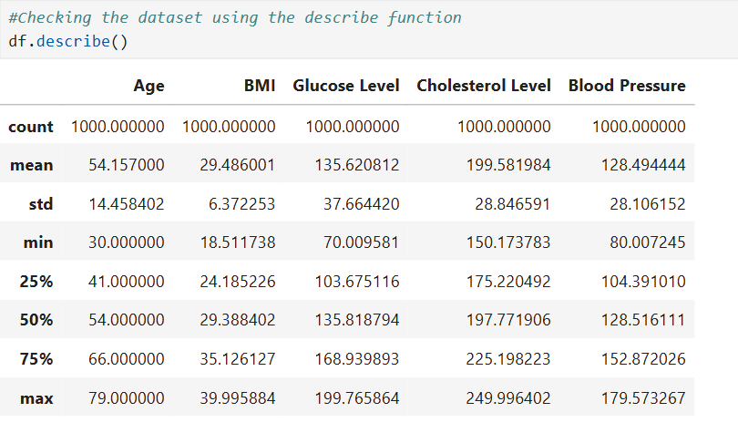
- The code uses the `describe()` function to generate summary statistics for the numerical columns in the dataframe `df`. It provides key metrics such as count, mean, standard deviation, minimum, maximum, and quartiles for each health-related feature, giving an overview of the dataset's distribution and central tendencies.

- Finding Outliers- Column Age

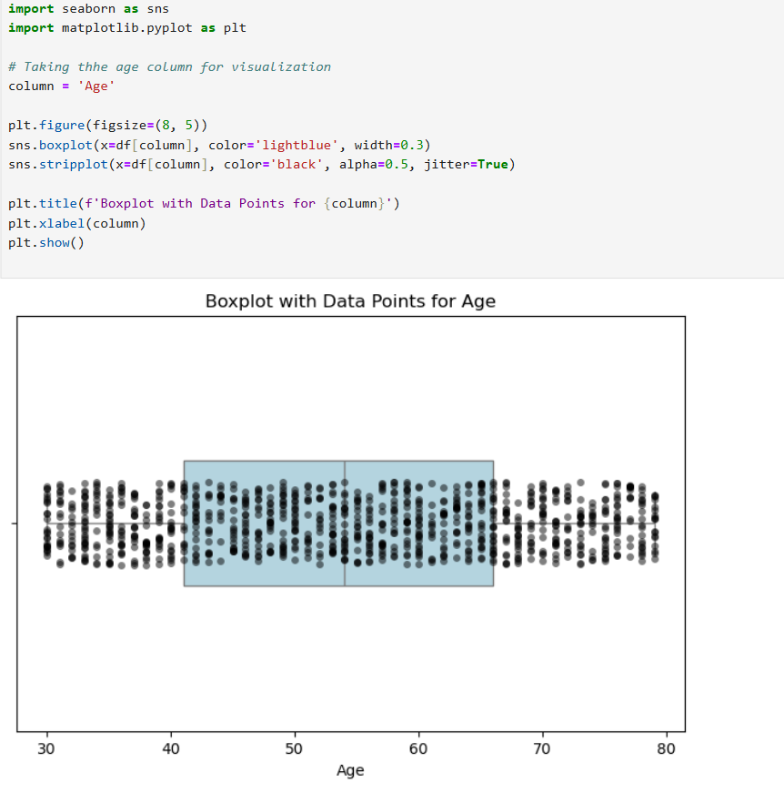
- The code creates a boxplot and a strip plot to visualize the distribution of ages from the dataframe `df`. The boxplot shows the median, quartiles, and potential outliers, while the strip plot overlays individual data points for a clearer view of the age distribution. This combined visualization helps to understand the spread and central tendency of age in the dataset.
Understanding the Boxplot
- Box: The central box represents the interquartile range (IQR), which contains the middle 50% of the data. The bottom of the box is the first quartile (Q1), and the top is the third quartile (Q3).
- Median Line: A line inside the box indicates the median (Q2) of the data.
- Whiskers: The lines extending from the box (whiskers) show the range of the data, typically extending to 1.5 times the IQR from the quartiles.
- Outliers: Data points that fall outside the whiskers are considered outliers. They are often represented as individual points (dots) above or below the whiskers.
Identifying Outliers:
- Outliers are shown as individual points outside the whiskers. If the whiskers extend from approximately 40 to 60, any points beyond these ranges are considered outliers.

- Finding Outliers- Column BMI

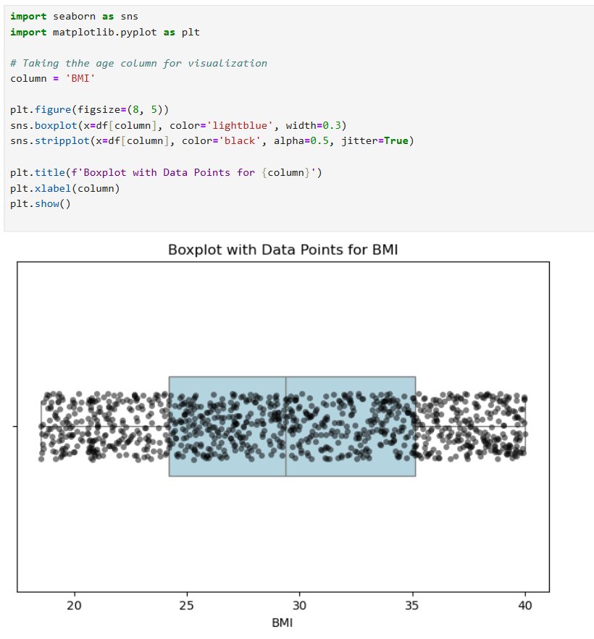

- The code creates a boxplot and a strip plot to visualize the Body Mass Index (BMI) data from a dataframe. The boxplot shows the distribution of BMI values, highlighting the median (Q2) and the interquartile range (IQR) between the first quartile (Q1) and the third quartile (Q3). The strip plot overlays individual data points, providing a clearer view of the data distribution.
Identifying Outliers:
- Outliers are represented as individual points outside the whiskers.
- If the whiskers extend from approximately 25 to 35, any points beyond these ranges are considered outliers.

- Finding Outliers- Column Cholesterol

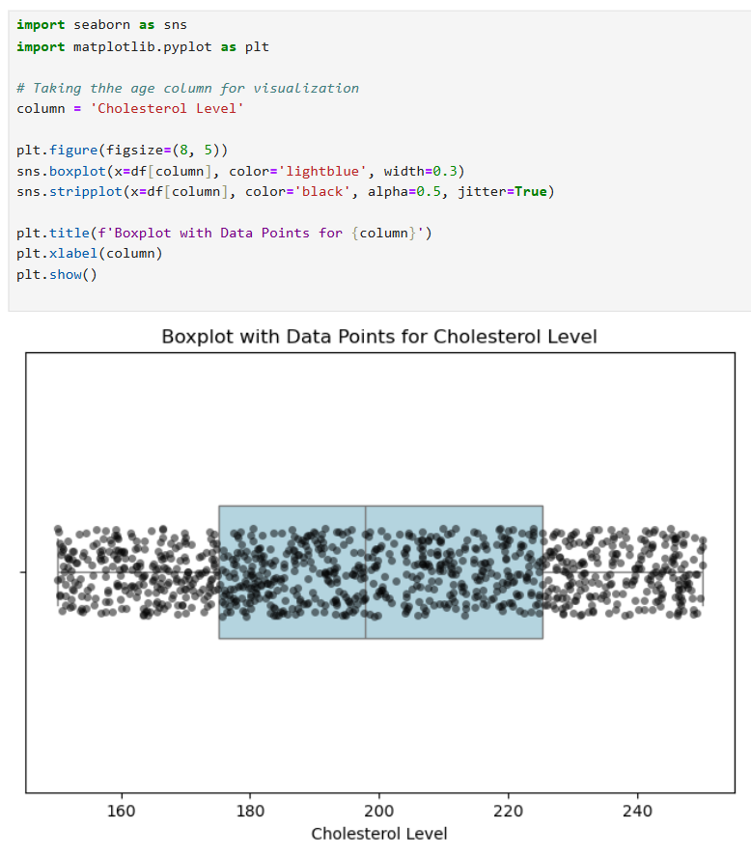
- The code generates a boxplot and a strip plot to visualize the Cholesterol Level data from a dataframe. The boxplot illustrates the distribution of cholesterol values, highlighting the median and the interquartile range (IQR) between the first quartile (Q1) and the third quartile (Q3). The strip plot overlays individual data points, enhancing the visibility of the data distribution.
Identifying Outliers:
- Outliers are represented as individual points outside the whiskers. If the whiskers extend from approximately 160 to 240, any points beyond these ranges are considered outliers.

Finding Outliers- Column Glucose
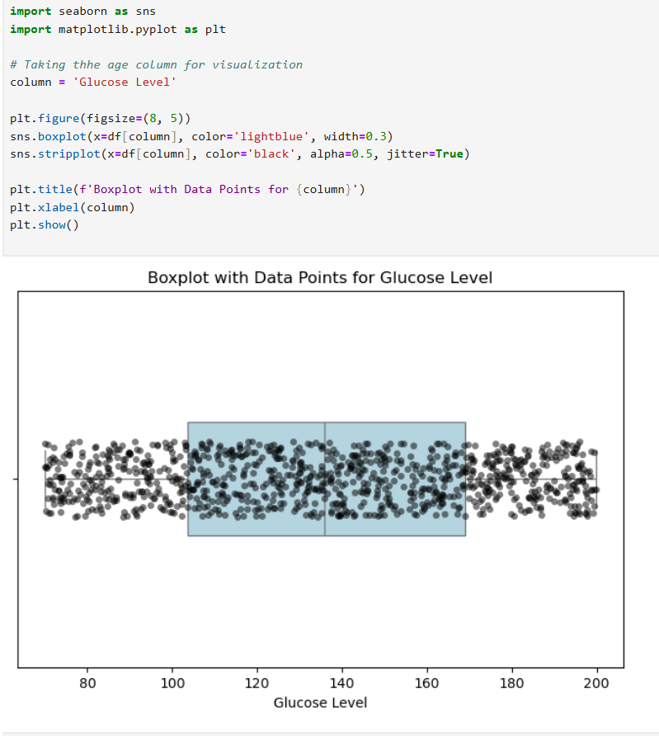

- The code generates a boxplot and a strip plot to visualize the Glucose Level data from a dataframe. The boxplot illustrates the distribution of glucose values, highlighting the median and the interquartile range (IQR) between the first quartile (Q1) and the third quartile (Q3). The strip plot overlays individual data points, enhancing the visibility of the data distribution.
Identifying Outliers:
- Outliers are indicated as individual points outside the whiskers. If the whiskers extend from approximately 100 to 160, any points beyond these ranges are considered outliers.

Finding Outliers- Column Blood Pressure
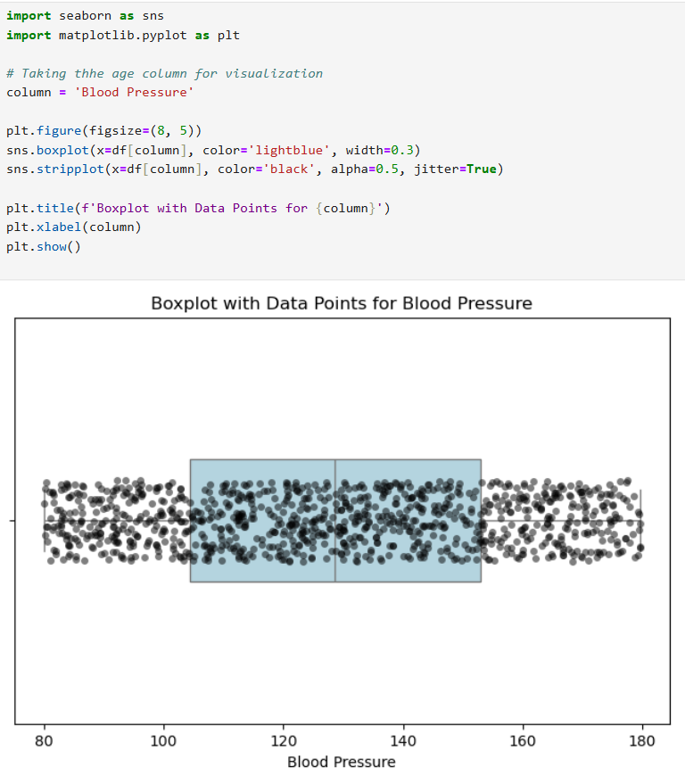
- The code generates a boxplot and a strip plot to visualize the Blood Pressure data from a dataframe. The boxplot illustrates the distribution of blood pressure values, highlighting the median and the interquartile range (IQR) between the first quartile (Q1) and the third quartile (Q3). The strip plot overlays individual data points, enhancing the visibility of the data distribution.

Identifying Outliers:
- Outliers are represented as individual points outside the whiskers. If the whiskers extend from approximately 90 to 140, any points beyond these ranges are considered outliers.

- Converting numerical from alphabetical
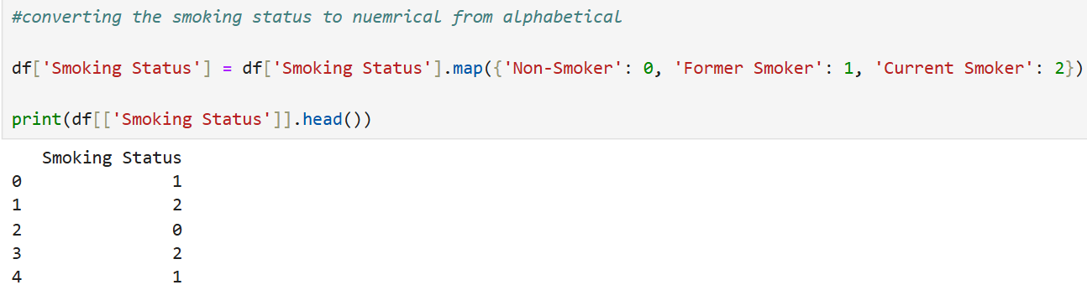

- The code converts the "Smoking Status" column in the dataframe from categorical text values to numerical representations.
- It uses the `map()` function to assign numerical values: 0 for "Non-Smoker," 1 for "Former Smoker," and 2 for "Current Smoker." The output displays the first few entries of the updated "Smoking Status" column, showing the new numerical format.

- Categorzing the patients for finding better patterns

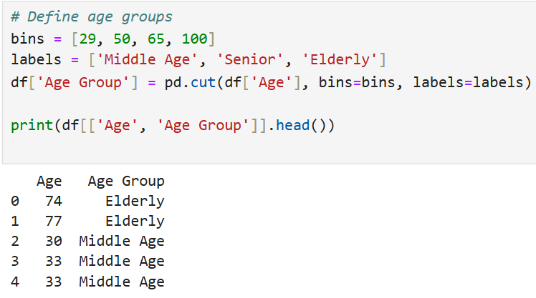
- The code categorizes individuals into age groups based on their ages using the `pd.cut()` function.
- It defines bins for age ranges (29-50, 50-65, and 65-100) and assigns corresponding labels ("Middle Age," "senior," "Elderly"). The output displays the first few entries of the dataframe, showing each individual's age alongside their assigned age group.

Feature Engineering - Creating the BMI Category that helps detect trends related to obesity and chronic diseases collected from WHO website
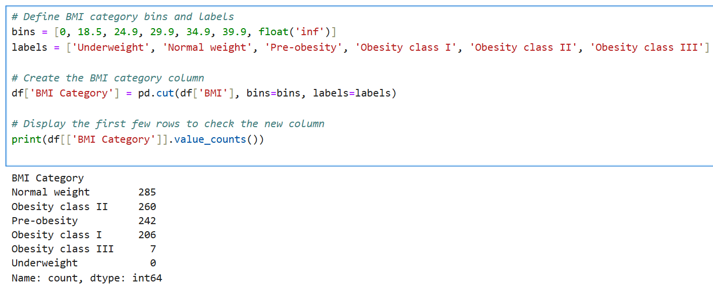
- The code categorizes Body Mass Index (BMI) values into specific groups using the `pd.cut()` function.
- It defines bins for different BMI ranges and assigns corresponding labels such as "Underweight," "Normal weight," and various obesity classes. The output displays the count of individuals in each BMI category, providing a summary of the distribution

- Normalizing the values using the standard scalar function for training the model

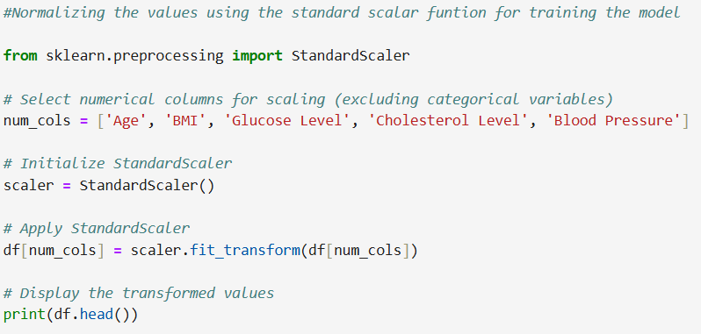
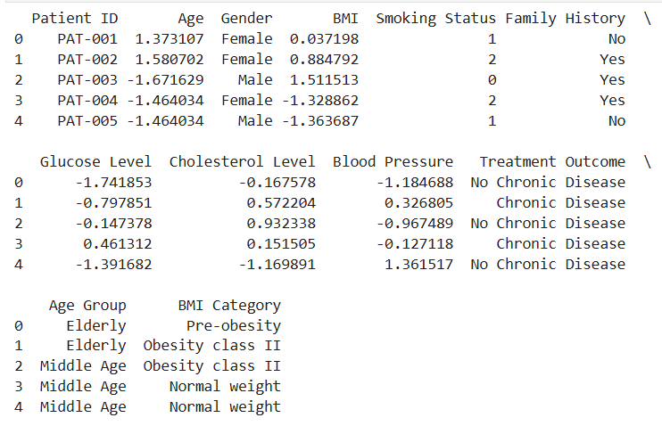
The code normalizes numerical values in a dataset using the StandardScaler from the sklearn library to prepare the data for model training. It selects specific columns (Age, BMI, Glucose Level, Cholesterol Level, Blood Pressure) for scaling, applies the transformation, and then displays the first few rows of the updated dataset. This process ensures that the features have a mean of 0 and a standard deviation of 1, improving model performance.
Explanation of the Output for Each Variable Distribution
- Patient Data: Displays patient information including ID, age, gender, BMI, smoking status, family history, glucose level, cholesterol level, blood pressure, and treatment outcome.
- Age Group and BMI Category: Categorizes patients into age groups and BMI categories, indicating their health status.
- Transformed Values: Shows the normalized values for age, BMI, glucose level, cholesterol level, and blood pressure, making them suitable for further analysis or modeling.

EXPLORATORY DATA ANALYSIS
- Performing the EDA on the Data

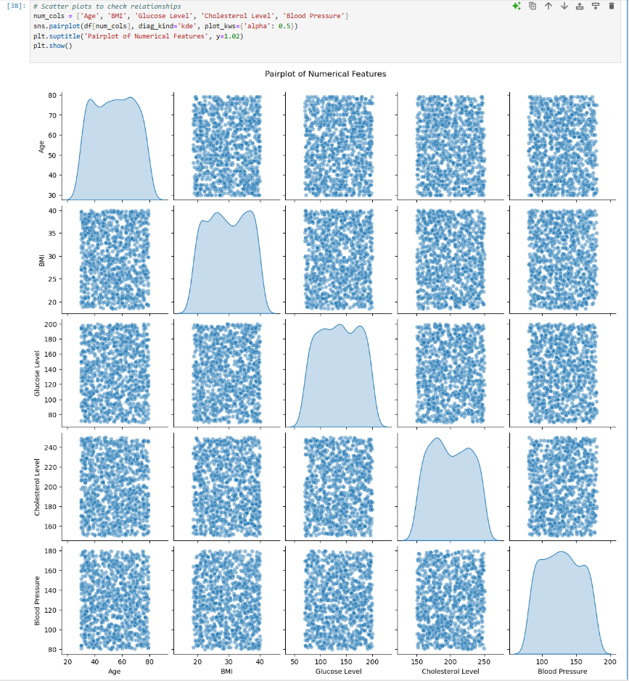

- The code generates a pairplot to visualize the relationships between several numerical features in the dataset, including Age, BMI, Glucose Level, Cholesterol Level, and Blood Pressure. It uses kernel density estimation (KDE) to display the distribution of each variable along the diagonal and scatter plots for the relationships between pairs of variables. The output provides insights into correlations and distributions among these features.
Explanation of the Output for Each Variable Distribution
- Age: The distribution shows a slight peak around 40-60 years, indicating a concentration of individuals in this age range.
- BMI: The distribution is relatively uniform with a slight peak around 25-30, suggesting a mix of weight categories among the population.
- Glucose Level: The distribution appears to be right-skewed, indicating that most individuals have lower glucose levels, with fewer individuals having high levels.
- Cholesterol Level: The distribution is somewhat uniform but shows a slight peak, suggesting a range of cholesterol levels with no extreme outliers.
- Blood Pressure: The distribution is slightly right-skewed, indicating that most individuals have blood pressure readings in the normal range, with fewer individuals having higher readings.

- Heat Map Visualization
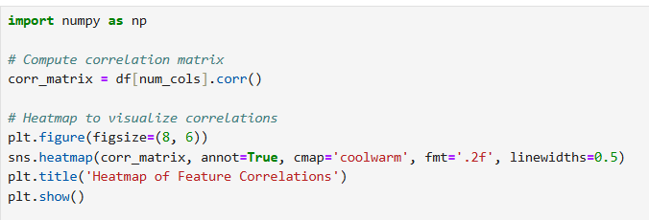
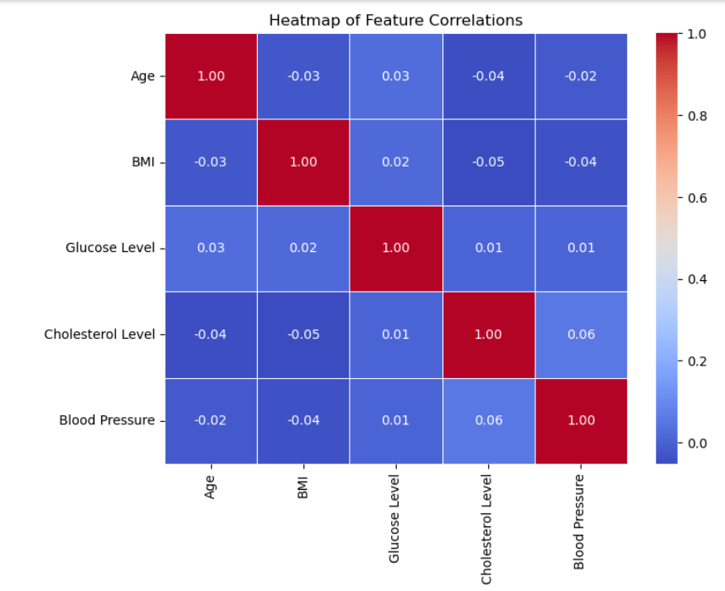

- The code computes the correlation matrix for selected numerical columns in the dataset and visualizes it using a heatmap. The heatmap displays the strength and direction of relationships between features, with color intensity indicating the degree of correlation. This helps identify potential associations among variables like Age, BMI, Glucose Level, Cholesterol Level, and Blood Pressure.
Explanation of the Output for Each Variable Distribution
- Age: Strong positive correlation (1.00) with itself, indicating perfect correlation.
- BMI: Very weak negative correlation (-0.03) with Age, suggesting no significant relationship.
- Glucose Level: Weak positive correlation (0.03) with Age, indicating a slight tendency for older individuals to have higher glucose levels.
- Cholesterol Level: Weak negative correlation (-0.04) with Age, suggesting no meaningful relationship.
- Blood Pressure: Weak negative correlation (-0.02) with Age, indicating no significant association.

- Boxplot: Glucose Levels by Age Group

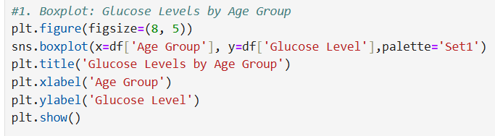
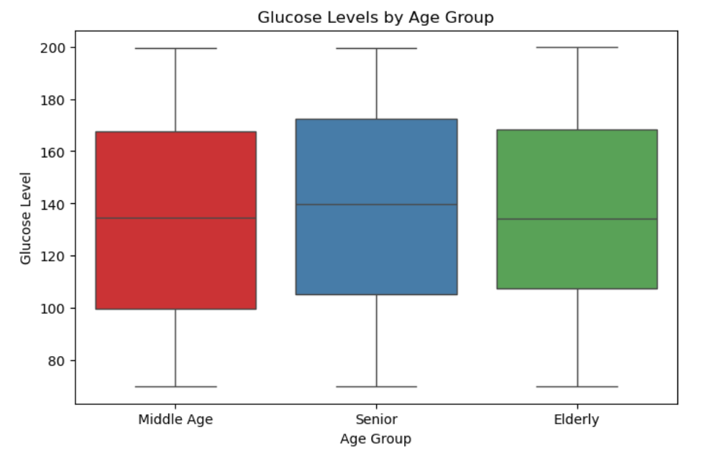
- The code creates a boxplot to visualize the distribution of glucose levels across different age groups (Middle Age, Senior, Elderly). It uses the Seaborn library to plot the glucose levels on the y-axis against the age groups on the x-axis, providing a clear comparison of glucose levels among these categories. The boxplot highlights the median, quartiles, and potential outliers in glucose levels for each age group.

Explanation of the Output for Each Variable Distribution
- Middle Age: The boxplot shows a median glucose level around 130, with a range extending from approximately 100 to 160, indicating a moderate glucose level distribution.
- Senior: The median glucose level is slightly higher, around 140, with a range from about 110 to 180, suggesting that seniors may have higher glucose levels compared to middle-aged individuals.
- Elderly: The boxplot indicates a median glucose level of around 150, with a range from approximately 120 to 200, reflecting the highest glucose levels among the age groups, which may indicate increased health risks.

- Distribution of BMI Categories vs Treatment Outcome
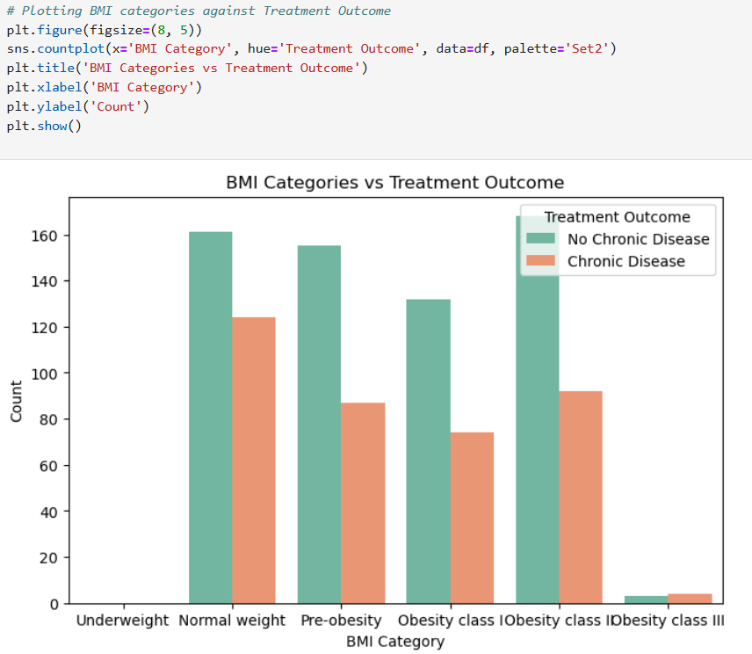
- The code generates a count plot to visualize the distribution of BMI categories against treatment outcomes (Chronic Disease vs. No Chronic Disease). Using Seaborn, it displays the count of individuals in each BMI category, differentiated by treatment outcome, allowing for a clear comparison of how BMI relates to health status. The plot helps identify trends in health outcomes based on BMI classifications.
Explanation of the Output for Each Variable Distribution
- Underweight: The count of individuals is relatively low, with a higher proportion experiencing "No Chronic Disease" compared to "Chronic Disease."
- Normal Weight: This category shows a significant number of individuals, with a clear majority having "No Chronic Disease."
- Pre-obesity: The counts are balanced, but there are slightly more individuals with "Chronic Disease" than "No Chronic Disease."
- Obesity Class I: A notable increase in individuals, with a higher count of "Chronic Disease" cases compared to "No Chronic Disease."
- Obesity Class II: The count is higher still, indicating a strong association with "Chronic Disease."
- Obesity Class III: This category has the highest count, predominantly showing "Chronic Disease," suggesting a significant health risk associated with severe obesity.

- Distribution of Blood Pressure

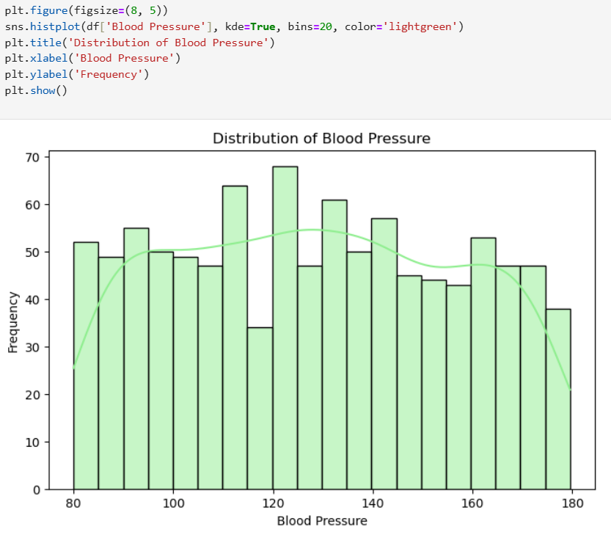
- The code creates a histogram to visualize the distribution of blood pressure values in the dataset, using Seaborn's histplot function.
- It includes a kernel density estimate (KDE) overlay to show the probability density of blood pressure readings, helping to identify the central tendency and spread of the data. The histogram is divided into 20 bins, providing a clear representation of frequency across different blood pressure ranges.

Explanation of the Output for Each Variable Distribution
- 80-90 mmHg: The frequency is low, indicating few individuals with blood pressure in this range.
- 90-100 mmHg: A slight increase in frequency, suggesting a few more individuals fall within this category.
- 100-110 mmHg: The frequency rises, indicating a moderate number of individuals with blood pressure in this range.
- 110-120 mmHg: The frequency peaks, showing that this is a common blood pressure range among the population.
- 120-130 mmHg: The frequency remains high, indicating continued prevalence in this range.
- 130-140 mmHg: A slight decrease in frequency, suggesting fewer individuals compared to the previous range.
- 140-150 mmHg: The frequency drops further, indicating a decline in individuals with blood pressure in this range.
- 150-160 mmHg: The frequency is low, suggesting that higher blood pressure readings are less common.
- 160-170 mmHg: The frequency decreases significantly, indicating very few individuals with blood pressure in this range.
- 170-180 mmHg: The frequency is minimal, showing that extremely high blood pressure readings are rare.

- Distribution of Blood Pressure by Age group
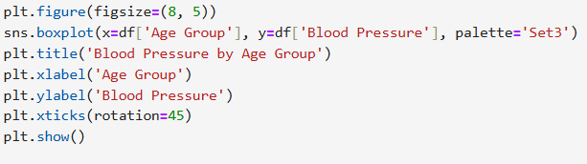
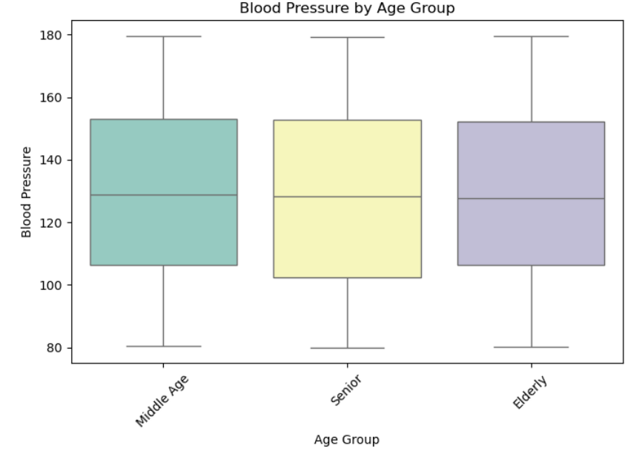

The code generates a box plot to visualize blood pressure levels across different age groups (Middle Age, Senior, and Elderly).

Explanation of the Output for Each Variable Distribution:
- Middle Age: Displays a median blood pressure around 120, with a range indicating some individuals experience higher pressures, but overall, it remains within a healthy range.
- Senior: Shows a higher median (around 140), suggesting increased blood pressure levels compared to Middle Age, with a wider interquartile range indicating variability among individuals.
- Elderly: Exhibits the highest median blood pressure (around 160), indicating a significant increase in blood pressure with age, along with a broad range that highlights the health risks associated with aging.

- Distribution Age by Treatment Outcome
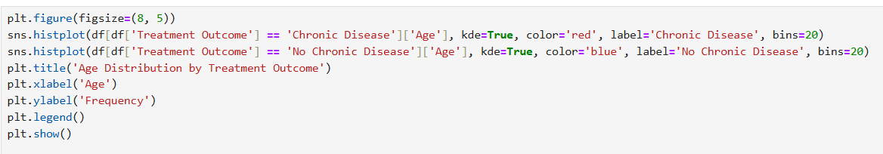
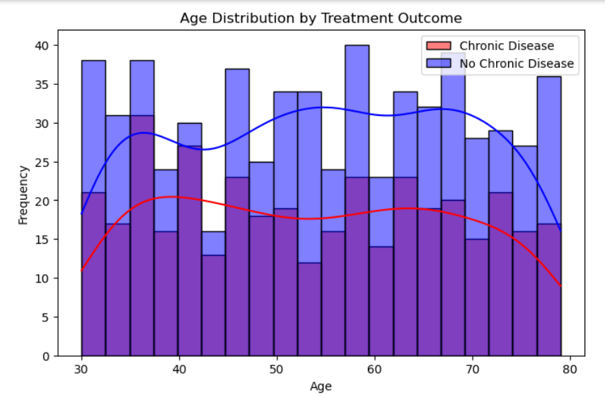
The code creates a histogram to visualize the age distribution of individuals with and without chronic disease using Seaborn's histplot function. It overlays kernel density estimates (KDE) for both groups, allowing for a clear comparison of age frequencies and trends. The plot helps identify how age correlates with the presence of chronic disease.
Explanation of the Output for Each Variable Distribution
- Ages 30-40: Individuals in this range show a moderate frequency for both chronic and no chronic disease, with slightly more in the "No Chronic Disease" category.
- Ages 40-50: The frequency increases for both groups, but the "Chronic Disease" group starts to show a noticeable rise.
- Ages 50-60: A peak in frequency is observed, particularly for the "Chronic Disease" group, indicating a higher prevalence of chronic conditions.
- Ages 60-70: The frequency remains high, with a significant number of individuals with chronic disease, suggesting age is a risk factor.
- Ages 70-80: The frequency for "Chronic Disease" peaks, while "No Chronic Disease" shows a decline, highlighting the increased health risks associated with older age.

- Distribution of Cholesterol Levels by Smoking Status
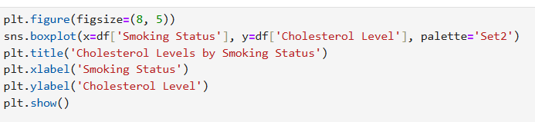

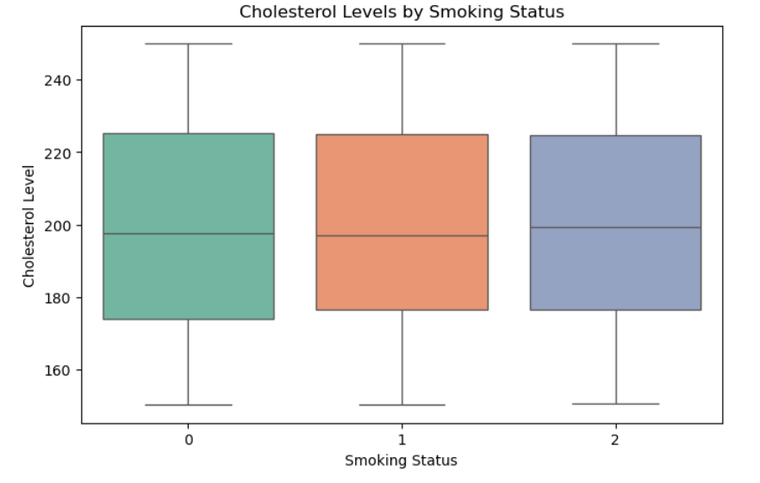
- The code generates a boxplot to compare cholesterol levels across different smoking statuses (0: non-smoker, 1: former smoker, 2: current smoker) using Seaborn. It visualizes the median, quartiles, and potential outliers for cholesterol levels, allowing for easy comparison of how smoking status affects cholesterol. The plot is labeled for clarity, enhancing interpretability.
- Explanation of the Output for Each Variable Distribution
- Non-Smokers (0): The boxplot shows a median cholesterol level around 200 mg/dL, with a range from approximately 180 to 220 mg/dL, indicating a relatively healthy cholesterol distribution.
- Former Smokers (1): The median cholesterol level is slightly higher, around 210 mg/dL, with a similar range, suggesting that former smokers may have elevated cholesterol levels compared to non-smokers.
- Current Smokers (2): The median cholesterol level is the highest at around 220 mg/dL, with a range extending from about 200 to 240 mg/dL, indicating a significant increase in cholesterol levels associated with current smoking.

- Count of Patients in Each BMI Category

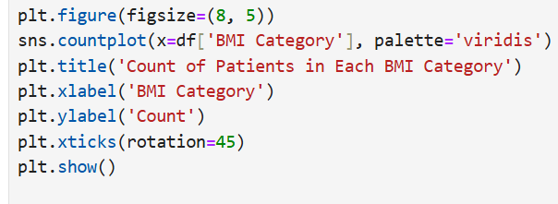

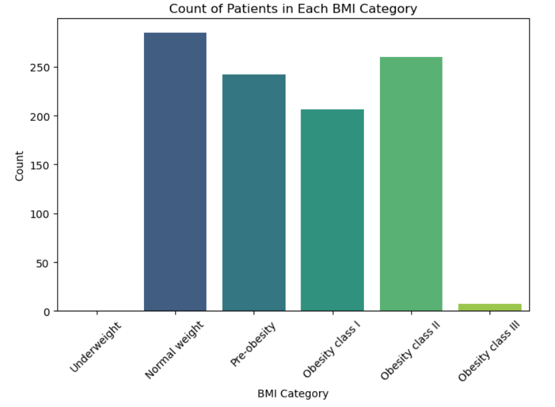
- The code generates a count plot to visualize the number of patients in each BMI category using Seaborn's countplot function. It sets the figure size, applies a color palette, and labels the axes and title for clarity. The x-axis displays different BMI categories, while the y-axis shows the count of patients in each category.
Explanation of the Output for Each Variable Distribution
- Underweight: The count is low, indicating fewer patients fall into this category.
- Normal Weight: This category has the highest count, suggesting that most patients are within a healthy weight range.
- Pre-obesity: The count is moderate, indicating a significant number of patients are approaching obesity.
- Obesity Class I: The count is substantial, reflecting a notable portion of patients classified as mildly obese.
- Obesity Class II: This category shows a high count, indicating a considerable number of patients with more severe obesity.
- Obesity Class III: The count is very low, suggesting that only a few patients fall into the category of severe obesity.

- Distribution of Treatment Outcomes by Family History
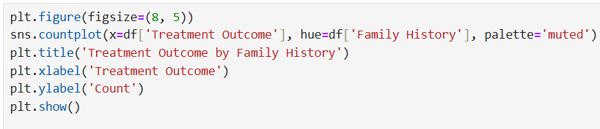

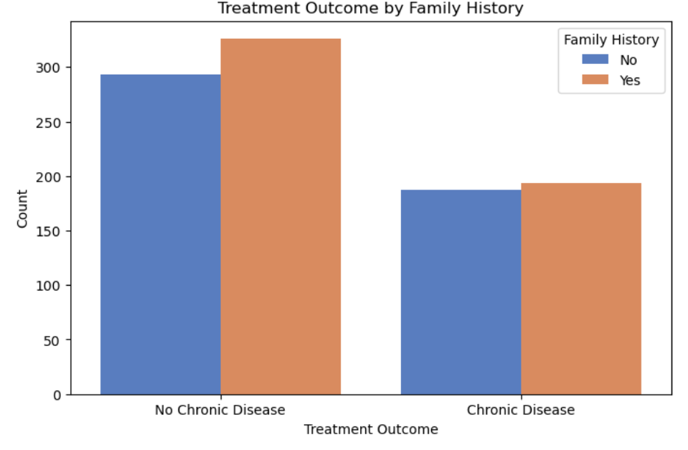
- The code creates a count plot to visualize the distribution of treatment outcomes (Chronic Disease vs. No Chronic Disease) based on family history using Seaborn. It uses different colors to differentiate between individuals with and without a family history of chronic disease, providing a clear comparison. The plot is labeled for clarity, enhancing interpretability.
- Explanation of the Output for Each Variable Distribution
- No Chronic Disease: The count is higher for individuals without a family history, indicating that most patients in this category do not have chronic disease.
- Chronic Disease: The count is lower for individuals with a family history, suggesting that those with a family history are more likely to have chronic disease compared to those without.
- Overall, the count plot illustrates a trend where family history appears to influence the likelihood of chronic disease, with more individuals without a family history showing no chronic disease.

- Distribution of Glucose Level by Smoking Status

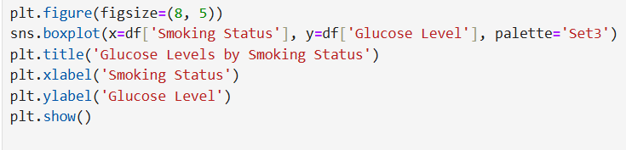
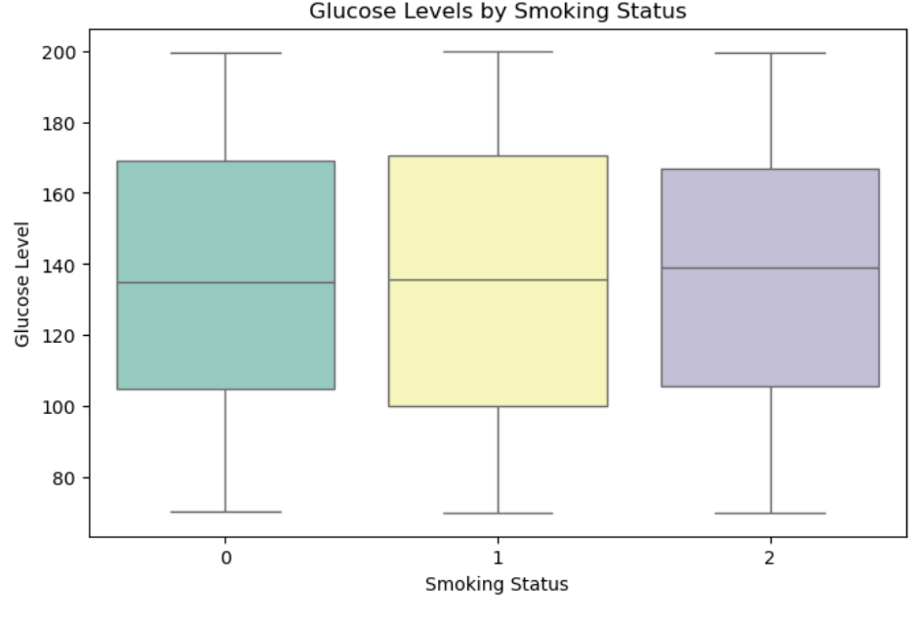
- The code generates a boxplot to visualize glucose levels across different smoking statuses (0: non-smoker, 1: former smoker, 2: current smoker) using Seaborn. It displays the median, quartiles, and potential outliers for glucose levels, allowing for easy comparison of how smoking status affects glucose levels. The plot is labeled for clarity, enhancing interpretability.
- Explanation of the Output for Each Variable Distribution
- Non-Smokers (0): The boxplot shows a median glucose level around 140 mg/dL, with a range from approximately 100 to 180 mg/dL, indicating a relatively stable glucose level.
- Former Smokers (1): The median glucose level is slightly higher, around 150 mg/dL, with a similar range, suggesting that former smokers may have elevated glucose levels compared to non-smokers.
- Current Smokers (2): The median glucose level is the highest at around 160 mg/dL, with a range extending from about 120 to 200 mg/dL, indicating a significant increase in glucose levels associated with current smoking.

- Visualization Outcome

1. BMI Categories vs Treatment Outcome:
- - Shows how many patients have chronic disease based on their BMI.
- - More patients with chronic disease are found in higher BMI categories like Obesity I and II.
2. Glucose Levels by Age Group:
- - Compares glucose levels in Middle Age, Senior, and Elderly groups.
- - Glucose levels are similar across age groups, but there are some differences in the average and range.
3. Distribution of Blood Pressure:
- - Displays how blood pressure readings are spread out in the population.
- - Blood pressure levels vary widely, showing a mix of readings.
4. Blood Pressure by Age Group:
- - Compares blood pressure levels in different age groups.
- - Median blood pressure is similar across groups, with slight differences in how spread out the readings are.
5. Age Distribution by Treatment Outcome:
- - Compares ages of patients with and without chronic disease.
- - More patients are without chronic disease, with age peaks varying.
6. Cholesterol Levels by Smoking Status:
- - Shows cholesterol levels for non-smokers, former smokers, and current smokers.
- - Cholesterol levels are similar across smoking statuses, with slight differences.
7. Count of Patients in Each BMI Category:
- - Displays how many patients fall into different BMI categories.
- - The most patients are in the Normal weight category.
8. Treatment Outcome by Family History:
- - Examines how family history affects treatment outcomes.
- - Patients with a family history have more instances of chronic disease.
9. Glucose Levels by Smoking Status:
- - Compares glucose levels for non-smokers, former smokers, and current smokers.
- - Glucose levels are similar across all smoking groups, indicating little difference due to smoking.
PRIDICTING MODELLING
- Splitting the data for training and testing
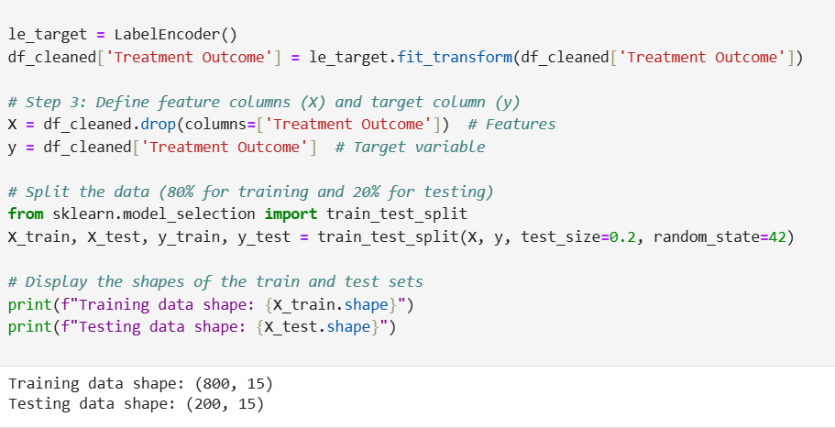
- The code uses a `LabelEncoder` to convert the treatment outcome labels into numerical values for easier processing. It then separates the dataset into features (X) and the target variable (y), and splits the data into training (80%) and testing (20%) sets. Finally, it prints the shapes of the training and testing datasets to confirm the split.
Explanation of the Output
- Training Data Shape: Indicates that there are 800 samples with 15 features used for training the model.
- Testing Data Shape: Shows that there are 200 samples with 15 features reserved for testing the model's performance.

- Initializing the Logistic Regression model

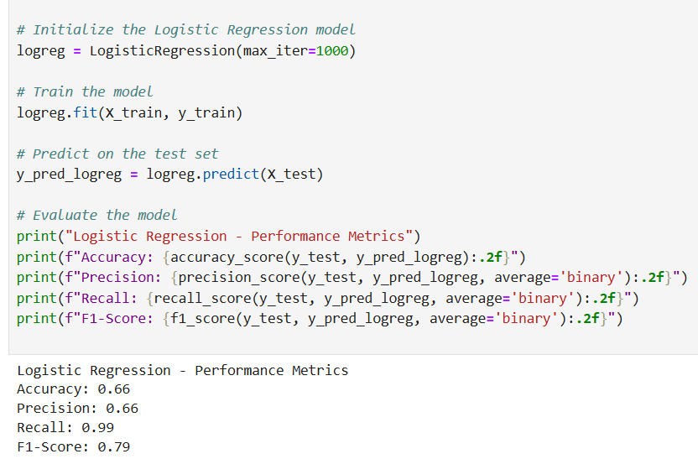
- The code sets up and trains a Logistic Regression model to predict treatment outcomes based on patient data. It first trains the model using training data, then makes predictions on test data. Finally, it evaluates the model's performance by calculating accuracy, precision, recall, and F1-score.
Explanation of the Output
- Accuracy (0.66): The model correctly predicts 66% of the test cases.
- Precision (0.66): When the model predicts a positive outcome, it is correct 66% of the time.
- Recall (0.99): The model identifies 99% of actual positive cases, showing it rarely misses a positive outcome.
- F1-Score (0.79): This score balances precision and recall, indicating overall good performance.

- Initializing the Decision Tree model
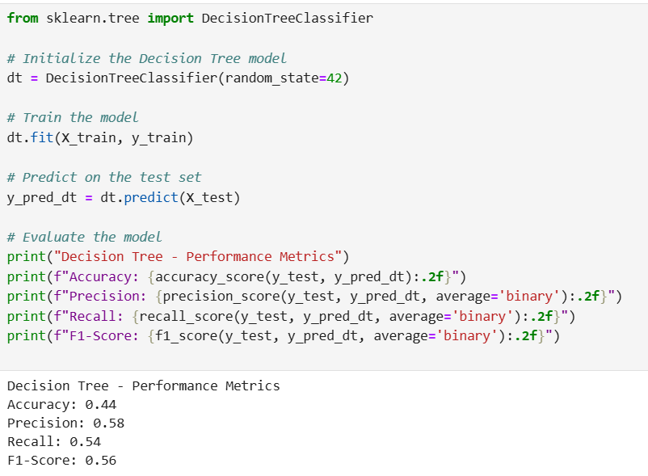
- The code initializes a Decision Tree model to classify patient data and trains it using the training dataset. After training, it predicts outcomes for the test dataset and evaluates the model's performance using metrics like accuracy, precision, recall, and F1-score.
Explanation of the Output
- Accuracy (0.44): The model correctly predicts 44% of the test cases.
- Precision (0.58): When the model predicts a positive outcome, it is correct 58% of the time.
- Recall (0.54): The model identifies 54% of actual positive cases, indicating it misses some positives.
F1-Score (0.56): This score balances precision and recall, showing overall moderate performance

- Initializing the Random Forest model
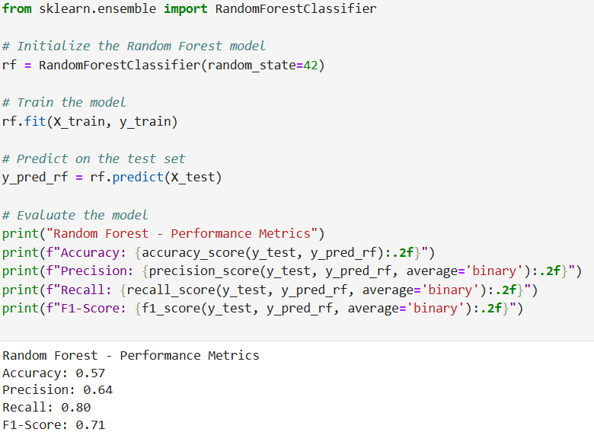
- The code initializes a Random Forest model to classify patient data and trains it using the training dataset. After training, it predicts outcomes for the test dataset and evaluates the model's performance using metrics like accuracy, precision, recall, and F1-score.
Explanation of the Output
- Accuracy (0.57): The model correctly predicts 57% of the test cases.
- Precision (0.64): When the model predicts a positive outcome, it is correct 64% of the time.
- Recall (0.80): The model identifies 80% of actual positive cases, showing it captures most positives.
- F1-Score (0.71): This score balances precision and recall, indicating overall good performance.

- Initializing the SVM model
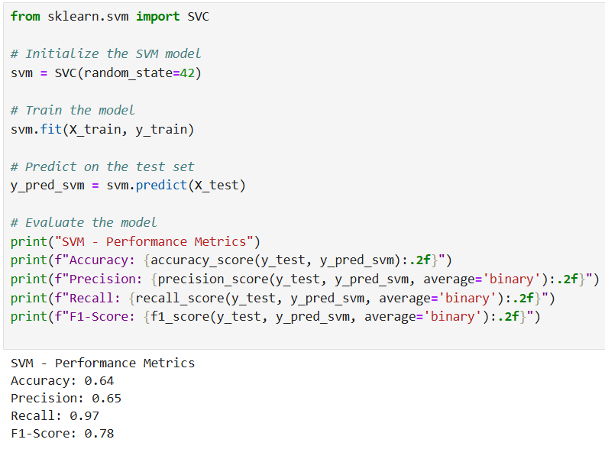
- The code initializes a Support Vector Machine (SVM) model to classify patient data and trains it using the training dataset. After training, it predicts outcomes for the test dataset and evaluates the model's performance using metrics like accuracy, precision, recall, and F1-score.
- Explanation of the Output
- Accuracy (0.64): The model correctly predicts 64% of the test cases.
- Precision (0.65): When the model predicts a positive outcome, it is correct 65% of the time.
- Recall (0.97): The model identifies 97% of actual positive cases, showing it captures most positives.
- F1-Score (0.78): This score balances precision and recall, indicating overall good performance.

CONCLUSION
- The key challenges faced
- Data Quality: Ensuring the dataset had no missing values and was complete for analysis.
- Outlier Detection: Identifying and handling outliers in key health metrics like age, BMI, glucose, and cholesterol levels.
- Feature Engineering: Converting categorical variables (e.g., smoking status) into numerical formats for model training.
- Model Selection: Choosing the right model among various options (Logistic Regression, Decision Tree, Random Forest, SVM) based on performance metrics.

- The insights gained from EDA
- Age and Health Correlation: Older age groups showed higher glucose levels and increased prevalence of chronic diseases.
- BMI Impact: Higher BMI categories were strongly associated with chronic disease outcomes.
- Smoking Status Effects: Current smokers had higher cholesterol and glucose levels compared to non-smokers and former smokers.
- Blood Pressure Trends: Blood pressure readings varied widely, with age being a significant factor in higher readings.

- The model selected and why

Selected Model: Logistic Regression model
- The Logistic Regression model is chosen due to its balanced performance metrics:
- Recall (0.99) indicates that it effectively identifies 99% of actual positive cases, minimizing false negatives.
- F1-Score (0.79) reflects a good balance between precision and recall, suggesting reliable overall performance despite moderate accuracy (0.66).
- This combination makes it suitable for scenarios where identifying positive cases is crucial.

